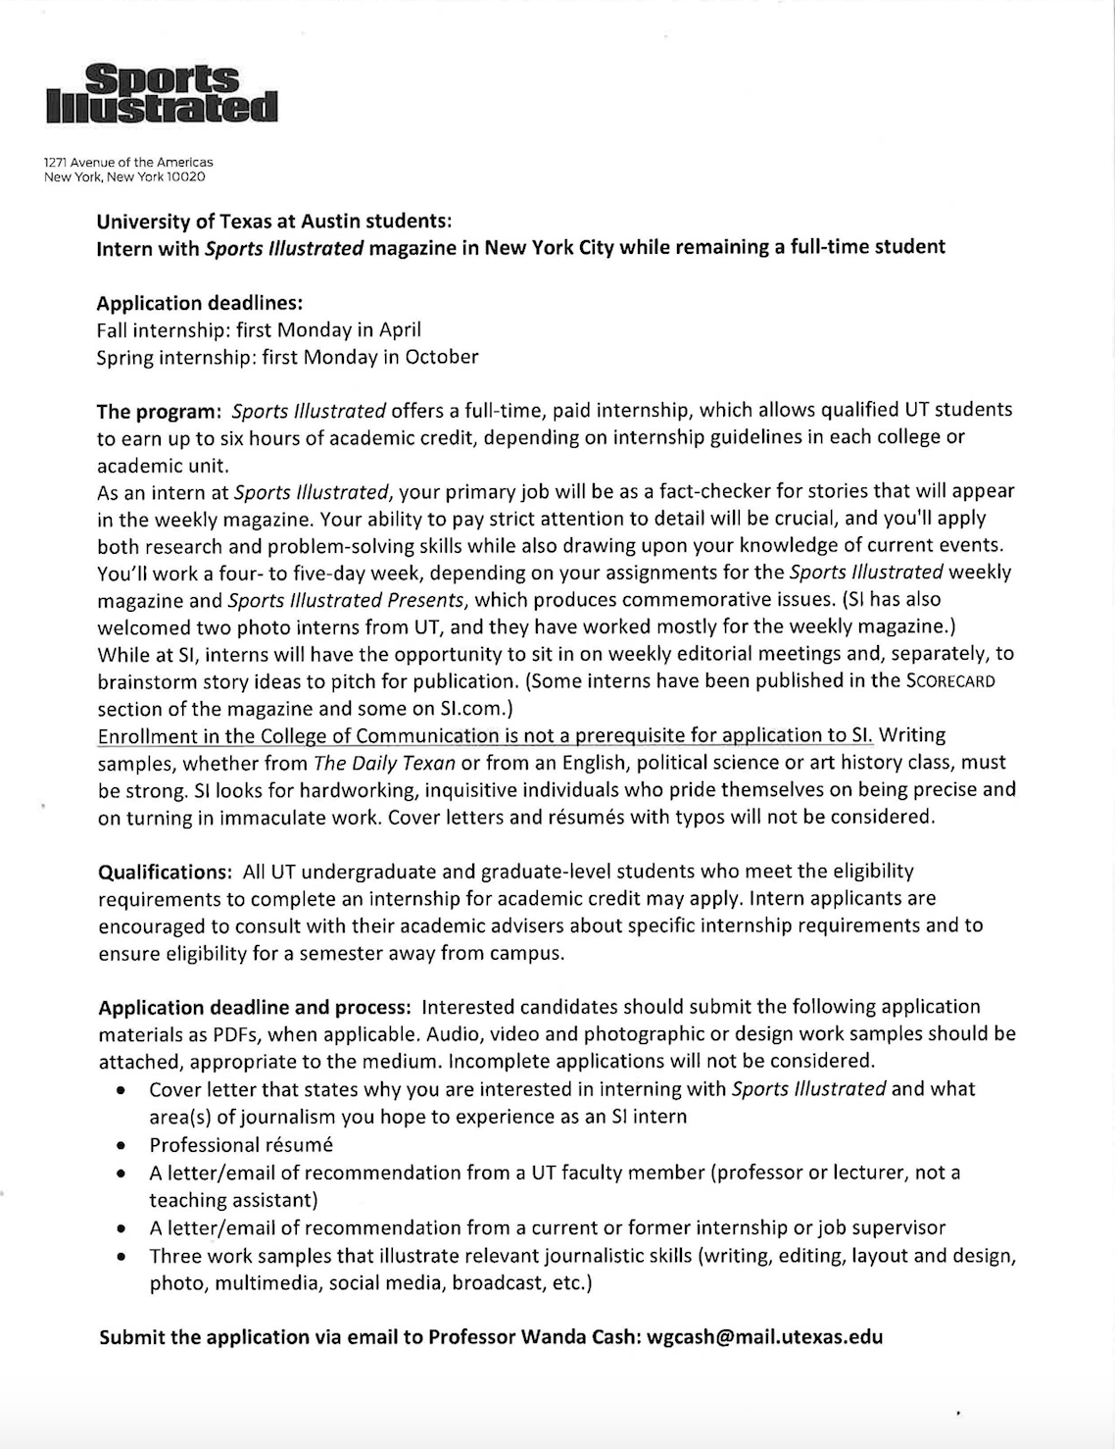

SUBMIT THE APPLICATION VIA EMAIL TO: kathleen.mcelroy@austin.utexas.edu

